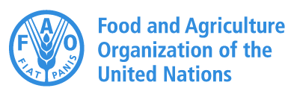


TECHNICAL GUIDELINES ON
ESTABLISHING A MODEL FARM FOR QUINOA

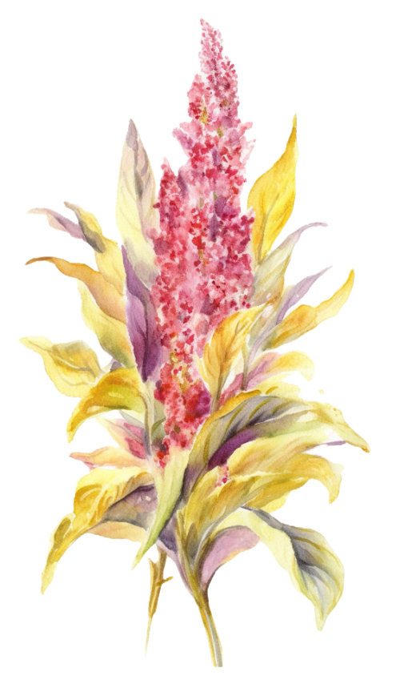
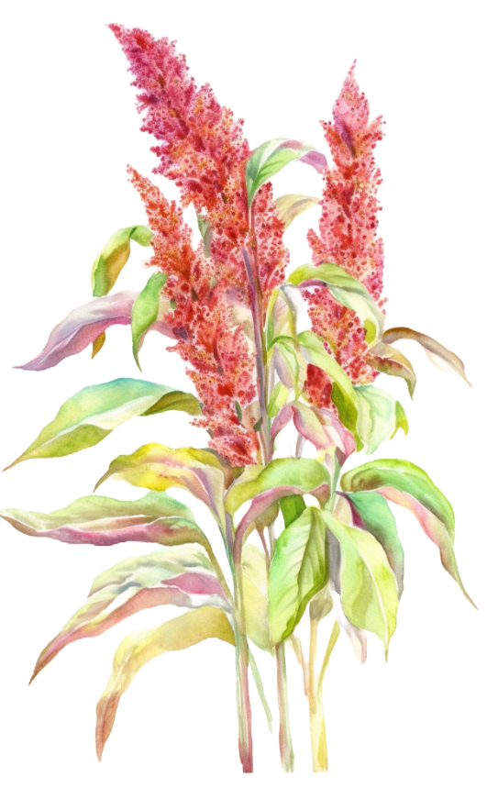
Department of Agriculture

Ministry of Agriculture and Livestock
September 2025

With technical assistant from Mr. Namgay Wangdi Assistant Agronomist, FAO, Bhutan

Table of Contents

List of Acronyms and Abbreviations ii
1 Introduction 1
2 Principles of Model Farm 2
3 Purpose of Pilot Model Farm for Quinoa 2
4 Steps for Designing a Model Farm 4
Step 1 Selection of site 4
Step 2 Geo Mapping of the site 5
Step 3 Soil and Water Analysis 5
Step 4 Farm planning, design, and layout 5
Step 5 Documentation of local knowledge, cropping systems, and traditional practices at the site 6
Step 6 Development of a cropping calendar 6
Step 7 Technical recommendation 6
Step 8 Investment plan and data to be collected for Return on Investment (ROI) 6
Step 9 Development of an Implementation Plan 7
Step 10 Registration and certification 8
5 Conclusion 8
6 References for further reading 11

List of Acronyms and Abbreviations

ARDC | Agriculture Research and Development Center
FAO | Food and Agriculture Organization
FYM | Farm Yard Manure
GIS | Geographic Information Systems
IPM | Integrated Pest Management
Kg | Kilogram
Km | Kilometers
LG | Local Government
MC | Moisture Content
NSSC | National Soil Service Center
Nu | Ngultrum
PoP | Package of Practices
ROI | Return on investment

Introduction
Quinoa (Chenopodium quinoa Willd.), a highly nutritious pseudocereal, has been successfully adapted across diverse agro-ecological zones in Bhutan. The country’s agricultural landscapes for quinoa cultivation are broadly categorized into high, mid, and low-altitude zones, each with unique conditions shaped by altitude, agroecology, land-use systems, and existing crop production practices. Farmers have gradually adapted their cropping systems to these environments and their household needs. While the best management practices for quinoa are generally applicable across zones, adoption at the farm level remains limited. Many farmers are unaware of the best management practices and reluctant to adopt new methods without clear evidence of their benefits. Therefore, establishing a Model Farm is an important step to demonstrate Good Agricultural Practices (GAP) in quinoa production, generate information to calculate the Return on Investment, Cost of Production, and highlight the differences between traditional and improved management practices. This technical guideline provides general recommendations for establishing a pilot model farm for quinoa production in Bhutan. It aims to serve as a practical reference for researchers, extension officers, and farmers to promote improved cultivation practices and sustainable production.
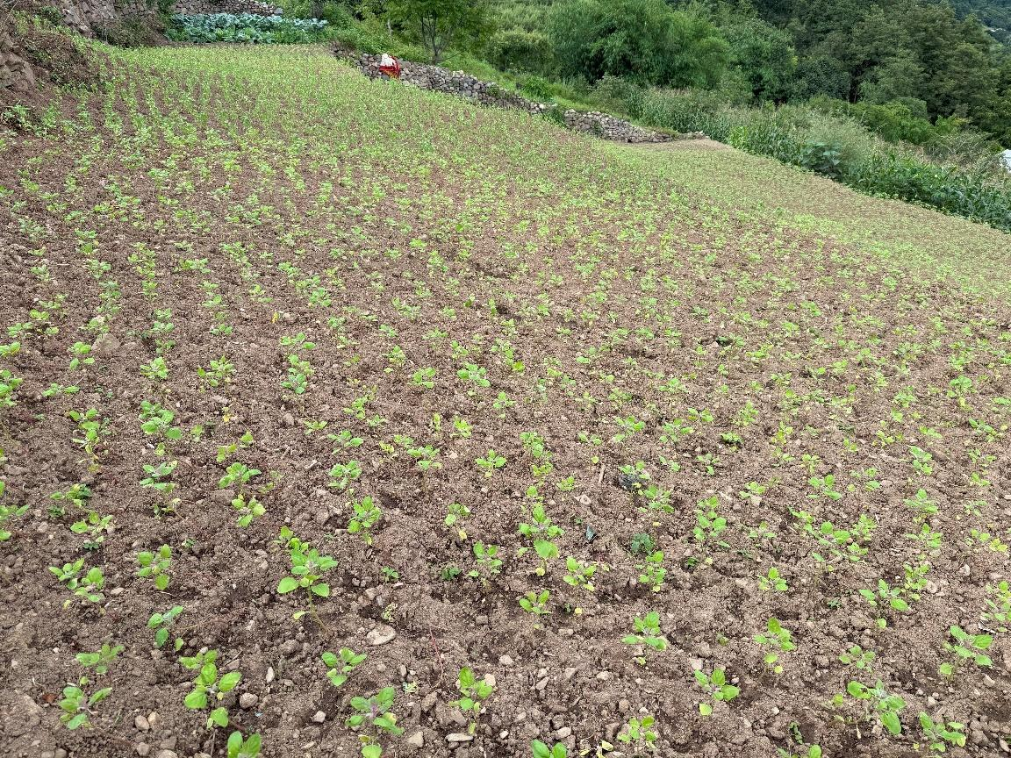
Figure 1. Quinoa model farm site at Bartsham, Trashigang

Principles of Model Farm
A Model Farm generally refers to a demonstration or experimental farm that is primarily used to showcase good agricultural practices and technologies. The underlying objectives of developing model agricultural farms are to promote best agricultural practices for demonstration, testing new technologies, education, training, and replication by others. The key elements of model agricultural farms include sustainability, resilience, regeneration, profitability, recycling, conservation, and utilization of biodiversity, as well as the conservation of soil, water, and the environment, and animal welfare. Model farms incorporate these key elements of sustainability to enhance productivity.

Purpose of Pilot Model Farm for Quinoa
Quinoa is a relatively new crop in Bhutan. Bhutanese farmers are gradually adopting and implementing various best practices for sustainable quinoa cultivation. The cultivation of quinoa is slowly evolving within the existing Bhutanese farming systems. To guide the farmers and demonstrate the best management practices for quinoa cultivation, establishing a Model Farm in strategic production areas is seen as a practical extension approach. The expected purpose and role of the Model Farms are:
- Serve as the strategic hub for demonstrating technologies, innovations, and best management practices for quinoa.
- Promote and showcase best management practices for soil, water, and biodiversity conservation and environmental sustainability to achieve long-term sustainability.
- Provide a space for engaging and training local communities in the area on all aspects of the quinoa value chain to transfer skills and knowledge.
- Serve as a real-time example to inspire farmers by demonstrating the most efficient and profitable cropping sequences and systems for quinoa.
- Promote product standardization and quality through certifications.
- Generate information and data to estimate Return on Investment (ROI).
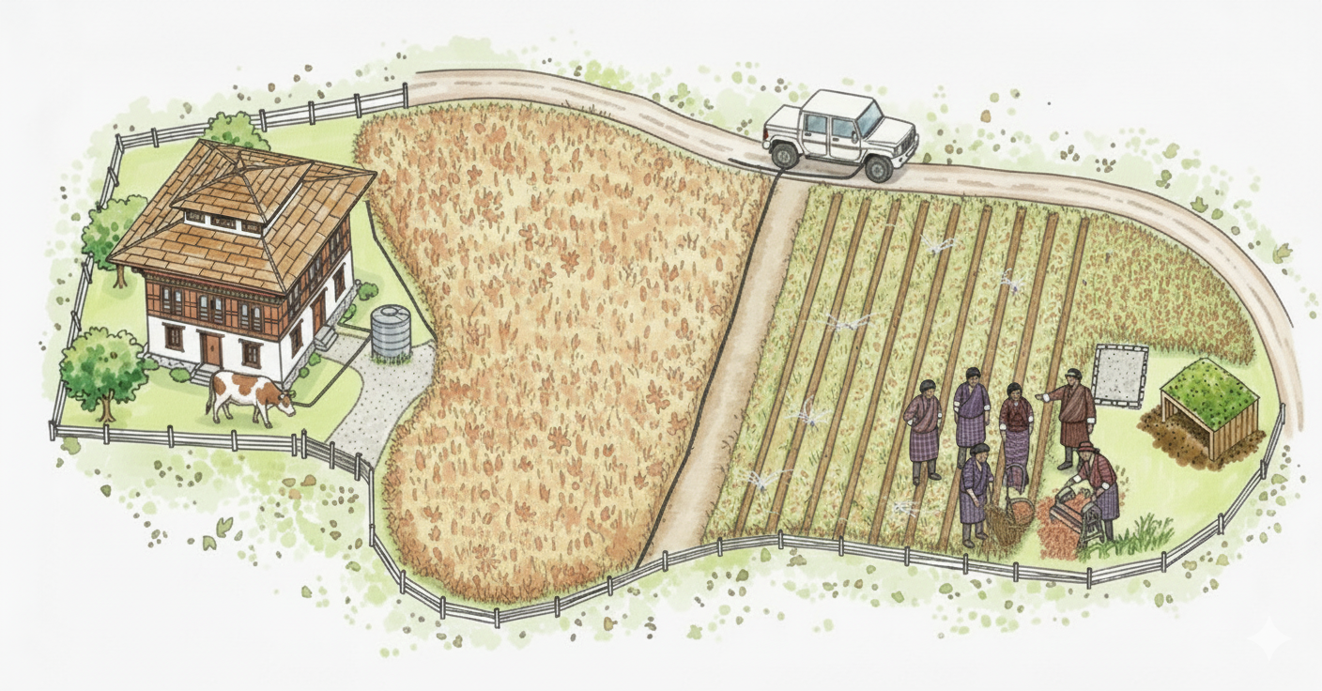
Figure 2. Pilot Model Farm
Figure 2. Quinoa Model Farm Sample

Steps for Designing a Model Farm
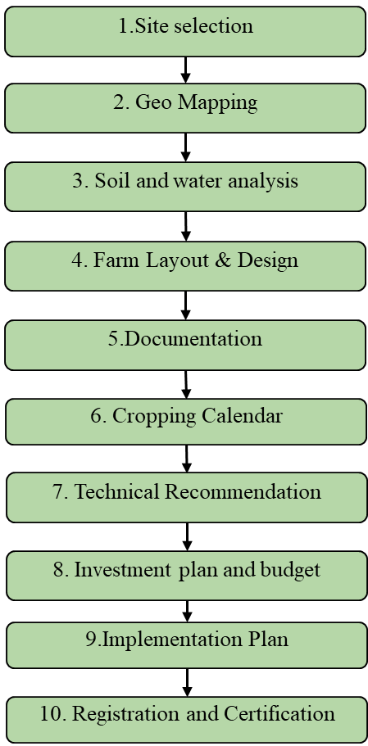

Establishing an agricultural farm entails a significant investment of resources. Farms are long-term investments with long-term objectives; hence, a systematic analysis of the situation is critical for planning the development of a model farm. Considering that most Bhutanese farmers operate on small farms of less than three acres, the recommended size of the model farm should be 0.50 to 1.0 acres. Theten broad steps for designing a model farm for quinoa are suggested below. A checklist intended to support the application of the guidelines is attached in Annexure 1.
Figure SEQ Figure \* ARABIC 1: Flow chart for steps in designing a Model Farm

Selection of site
The selection of the site is the first and most important step. The site for the model farm should be in a strategic location that is easily accessible to most of the communities. It should represent a defined quinoa production zone, either high, mid, or low. Every production landscape is unique and differs from others; therefore, selecting a representative site is critical. The site selection should be discussed and finalized in consultation with Dzongkhag and Local Government (LG) officials and communities. The important checklists for site selection are:
- Access to the site
- Slope and drainage of the site
- Access to water and electricity
- Consent and agreement of the farmer
- Challenges (eg, wildlife issues, irrigation)

Geo Mapping of the site
Once the site is selected and finalized with the consent of the farmer, the geo-location and mapping of the model farm should be done with the support of a Geographical Information System (GIS) expert. The boundary should be demarcated with iron angles. During the mapping, all other ancillary facilities, such as water sources, electricity, and access roads, required for the model farm should also be mapped. The temperature and precipitation data for the site should be obtained from the nearest meteorological station and analyzed to gain an understanding of the site's climate.

Soil and Water Analysis
After the site is finalized, sampling of soil and water should be done with the support of an expert from the Agriculture Research and Development Center (ARDC) or from the National Soil Services Center (NSSC). The soil nutrient management strategies for the farm, crop choice, and other decisions will be guided by the analytical results.

Farm planning, design, and layout
The model farm design should be based on the interests, preferences, needs, and farming context of farmers. This requires a detailed discussion with the farmer. Before implementing the activities, the design and layout of the farm should be planned, which includes all infrastructures, such as land development, fencing, irrigation facilities, compost shed, and any other physical infrastructure. Quinoa is not a perennial crop. It will be cultivated in sequence or in rotation with another crop, for which due consideration in planning is essential. The choice of fence type will depend on the problems faced by the cooperative farmer and should be thoroughly consulted. The farm design should be discussed with relevant stakeholders and agreed upon. The implementation of the plan is to be done once the design and layout are approved and finalized.

Documentation of local knowledge, cropping systems, and traditional practices at the site
Local experiences and knowledge are vital for the success of the model farm. Farmers have the best understanding of the regional situation and should be consulted as active stakeholders of the model farm. The cropping system, crop rotations, cropping sequences, and details of all agricultural practices at the site should be documented as the key input for recommending operations in the model farm. The data on yield, production, and input use will be required to estimate the ROI. The data collection format is presented in step 11.

Development of a cropping calendar
Using the inputs from step 5 and based on the recommendations of an experienced technical expert on quinoa cultivation, a cropping calendar should be developed for the site.

Technical recommendation
Depending on the agroecosystem, agroecological setting, and knowledge obtained from farmers and technical experts, technical recommendations should be made for variety, sowing time, soil nutrient management, and irrigation requirements. The recommendations should be based on the Package of Practices (PoP) for Quinoa and other relevant technical recommendations considering all elements of a model farm. Crop rotations and crop combinations should be identified, with consideration for the need to make the model farm sustainable, resilient, and profitable. Effective pest and disease management on the model farm requires weekly field scouting, early detection using simple tools like sticky traps, and adherence to Integrated Pest Management (IPM) principle prioritizing non-chemical methods and documenting all actions to support timely interventions and future improvements.

Investment plan and data to be collected for Return on Investment (ROI)
To accomplish the desired objectives of the model farm, investment is necessary. Resources are always scarce, and there are no freebies. It is crucial to develop a realistic investment plan that is built around the objectives and targets of the model farm. It is essential to detail out and segregate the fixed cost, variable cost, and the final returns from the investments. It is also crucial to list out the details of the different inputs used. This data will be used for calculating the ROI, so it is imperative to collect all relevant costs incurred for establishing the model farm. Additional data for the ROI should be collected after the crop is harvested. Data such as total production after threshing, MC of the grain during weighing, and post-harvest losses are essential for calculating the total returns from the model farm. Although the farmer may own the land, the rental value of the land should be estimated to calculate ROI and cost of production.
Table 1: Details of the investment plan and data to be collected
SN | Variables | Unit | Quantity | Cost per unit (Nu) | Total cost (Nu)
A. Fixed Cost
i | Fencing | Km
ii | Irrigation development | Km
ii | Land development | Acre
iv | Electricity connection | Km
v | Compost Shed development | No.
vi | Procurement of Farm Machinery by Type | Nu.
vii | Land Rental | Nu.
 | Total Cost | Nu.
B. Variable Cost
i | Cost of Field Preparation | Acre
ii | Fertilizers and manure | Kg
iii | Seed | Kg
iv | Pesticides | No.
v | Labour for Sowing | No.
vi | Labour for Weeding and irrigation | No.
vii | Labour for Chemical Application | No.
vii | Labour for Harvesting, threshing, and cleaning | No.
 | Total Variable Cost | Nu.
C | Total Fixed Cost + Total Variable Cost
D | Return
i | Total Production | Kg
ii | Grain MC | %
iii | Post-Harvest Loss (PHL) | Kg
iv | Selling Price (SP) | Nu.
 | Total returns | Nu. | (Adjusted Yield*SP)-(PHL*SP)

Development of an Implementation Plan
The final step involves developing an implementation plan and executing the planned activities. The production targets can be set annually.

Registration and certification
The model farm could be registered and certified, depending on the type of standards it adopts. Farmers can either register for Good Agriculture Practice (GAP) certification, Organic certification like the Local Organic Assurance Scheme (LOAS), Third Party Certification or the Geographical Indication Environment and Sustainability (GIES). This will help in product standardization and marketing.

Conclusion
Due to the mountainous terrain and diverse agroecology, there is considerable variation in climate and geophysical conditions over short distances. Each production landscape differs significantly in temperature, rainfall, and cropping systems. Farmers have traditionally adapted their cropping systems based on their experience with the local agro-ecosystem and their needs.
Therefore, a one-size-fits-all, standardized approach to designing pilot model farms is neither practical nor effective. The planning, design, and layout of these farms must stay flexible and adaptable, customized to the specific features of each site and aligned with the needs and priorities of the local farming community.
These 10 steps are designed to serve as a practical reference for establishing a pilot model farm for quinoa, promoting adaptable and sustainable practices that honor local conditions and farmers' knowledge.

Annexure
Annexure 1: Plan Execution Checklist
Step | Activity | Notes
1. Site Selection | ☐ Accessible to farmers  ☐ Representative of high/mid/low altitude  ☐ Good slope & drainage  ☐ Reliable water source  ☐ Electricity access  ☐ Farmer’s consent
2. Geo-Mapping | ☐ GPS/Geo-coordinates recorded  ☐ Boundary demarcated  ☐ Irrigation & access roads marked  ☐ Climate data collected (temp, rainfall)
3. Soil & Water Analysis | ☐ Soil samples collected & tested  ☐ Water source tested for irrigation  ☐ Soil pH & nutrients recorded  ☐ Recommendations obtained from NSSC/ARDC
4. Farm Layout & Design | ☐ Farm map prepared  ☐ Land leveling/fencing planned  ☐ Compost/manure shed site identified  ☐ Irrigation design planned  ☐ Crop rotation/diversification included
5. Documentation of Local Knowledge | ☐ Existing cropping system recorded  ☐ Traditional practices documented  ☐ Local yield & input use noted
6. Cropping Calendar | ☐ Suitable variety identified  ☐ Sowing date set (per altitude)  ☐ Fertilizer schedule prepared  ☐ Weeding & irrigation schedule  ☐ Harvest & post-harvest plan
7. Technical Recommendations | ☐ PoP guidelines followed  ☐ Seed rate & spacing confirmed  ☐ Fertilizer & FYM inputs set  ☐ Pest & disease IPM strategy prepared  ☐ Crop rotation with maize/potato/rice included
8. Investment Plan & Budget | ☐ Fixed costs (fencing, irrigation, tools)  ☐ Variable costs (seed, manure, labor, inputs)  ☐ Expected yield & income calculated  ☐ Profitability compared with farmer practice
9. Implementation Plan | ☐ Roles & responsibilities assigned  ☐ Seasonal work calendar prepared  ☐ Training/field day scheduled  ☐ Monitoring visits planned
10. Registration & Certification | ☐ Farm registered and certified

References for further reading
- Ludwig von Bertalanffy (1973). Agricultural and farm systems- Concepts and Definitions. https://www.fao.org/4/w7365e/w7365e04.htm#:
- Katwal, T. B., & Bazile, D. (2020). First adaptation of quinoa in the Bhutanese mountain agriculture systems. PLOS ONE, 15(1), e0219804. doi:10.1371/ journal.pone.0219804.
- Katwal,TB., Wangdi, N., and Giri, PL., (2018). Adaptation of Quinoa in Bhutanese Cropping Systems. Bhutan Journal of Agriculture. 2018; Issue II Volume I.
- Katwal, T.B. (2018). Quinoa: General Information and Package of Practices, 2018. Field Crops Program, Research and Development Center, Yuispang. Department of Agriculture, Ministry of Agriculture and Forests, Thimphu.
- Quinoa General Information and Package of Practices. 2025. Department of Agriculture, Ministry of Agriculture and Livestock, Thimphu.
- Quinoa Standard Operating Procedure: A field guide. 2025. Department of Agriculture, Ministry of Agriculture and Livestock, Thimphu.

